

GREAT DAWLEY TOWN COUNCIL

Dawley Town Hall
New Street, Dawley, Telford. TF4 3JR

M54 Junction 6, take the A5223 towards Ironbridge
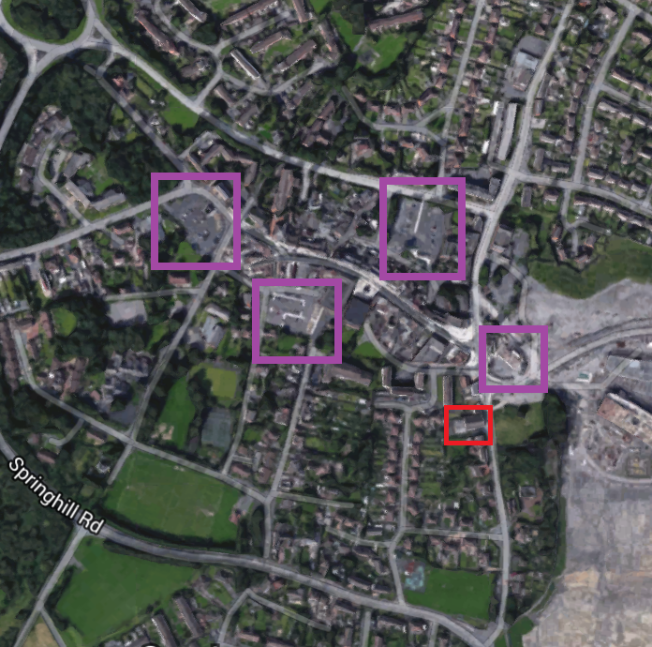
lights straight ahead, traffic lights straight ahead
Island 2nd left Dawley Road towards Heath Hill

Car Park A
At Island take 3rd exit Spring Hill
1st Left, follow road around
Car park on right hand side
Car Park C
Car Park B
At Island take 3rd exit Spring Hill
1st Left, follow road around
past car park on right hand side
2nd left George Street
Car Park on the right hand side

Car Park C
At Island take 2nd exit Captain Webb Drive
2nd right in Meadow Road
Car Park on the left

Car Park D
At Island take 3rd exit Spring Hill
Traffic lights turn left – New Street
Past Town Hall on left
Car park on the right hand side
After the hoarding

Dawley Town Hall

